Incident Response Report

Incident ID
IR-2026-01-CREATOR-001

Incident Title
Suspected Creator-Targeted Advance-Fee / Identity Harvesting Scam

Incident Category
Social Engineering
Fraud / Financial Scam
Phishing (Non-Credential)

Severity
Medium

Date / Time Detected
20 January 2026

Detection Method
Manual review of suspicious inbound email
Email header and content analysis
Correlation of initial outreach and follow-up email

Executive Summary
An external sender attempted to socially engineer the organization into a fraudulent creator partnership by advertising high-value compensation and requesting upfront coordination details through an external form.
Although the messages passed standard email authentication checks (SPF/DKIM), analysis identified multiple indicators consistent with advance-fee fraud and identity harvesting. The attempt was detected early, no data was submitted, and no financial loss occurred.
The attacker-provided link (hxxps://sweep-invite[.]digital/connect-creator) was accessed in a controlled environment to observe redirect behavior and data-collection activity.
The site presented a multi-step creator onboarding workflow designed to profile YouTube creators and establish legitimacy through branding and social proof. Upon completion of the profiling steps, the workflow redirected users to a look-alike Google authentication page hosted on sweep-auth[.]app, impersonating Google OAuth login functionality.
This final redirect represents a credential-harvesting attempt, intended to capture Google account credentials under the guise of YouTube channel verification. No legitimate Google authentication endpoints were used.

Scope & Impact
Affected Assets:
• Business inbox: inquiry[@]mydfir[.]com

Attack Analysis
Initial Vector:
• Direct email outreach to a public-facing business inbox
Observed Techniques:
• Impersonation and false authority
• Advance payment baiting
• Borrowed credibility using real creators
• Redirection to attacker-controlled external form
Kill Chain Stage:
• Reconnaissance
• Delivery
• Social Engineering
(No execution or persistence achieved)

Key Findings
Sender Infrastructure:
• Emails sent from free consumer email accounts ([@]libero[.]it)
• Origination traced to residential / consumer IP addresses
• No evidence of professional business or production infrastructure
Financial Scam Indicators:
• '50% upfront via your preferred method' language
• Undefined payment rails (no invoicing or escrow)
• Pattern consistent with advance-fee and fake payment scams

Indicators of Compromise (IOCs)
Email Addresses:
- modash_partners[@]libero[.]it
- sweep-auth[.]app
- hxxps://sweep-invite[.]digital/connect-creator
- hxxps://sweep-auth[.]app/?continue=hxxps://myaccount[.]google[.]com/
- collab[.]modash[@]libero[.]it
Domains:
• libero[.]it
• sweep-invite[.]digital
File Hashes
sweep-invite[.]digital
SHA256: f0b3fc7ee78aa50031b22838117923596b320681275e5d786d8b57384f857fdf
MD5: d9608f70fbb357f5061a4734048c34f2
IP Addresses:
• 154[.]219[.]17[.]118 – Residential origin (initial outreach)
• 79[.]37[.]102[.]71 – Residential origin (reply)
• 213[.]209[.]10[.]18 – Libero outbound mail server
• 213[.]209[.]13[.]31 – Libero outbound mail server
Subject Lines:
• Seria
• Re: Seria

Containment Actions Taken
• No further engagement with sender
• Emails preserved with full headers
• IOCs documented for tracking and correlation

Recommendations
• Block sender email addresses and domains
• Flag sweep-invite[.]digital as malicious internally
• Retain IOCs for future detection
Preventive:
• Awareness training on creator-targeted scams
• Require legal entity and contract before payment discussions
• Email rules to flag high-value offers from free email providers

Lessons Learned
• Passing SPF/DKIM does not equate to legitimacy
• Creator-economy scams increasingly mimic real collaborations

Attachments / Evidence

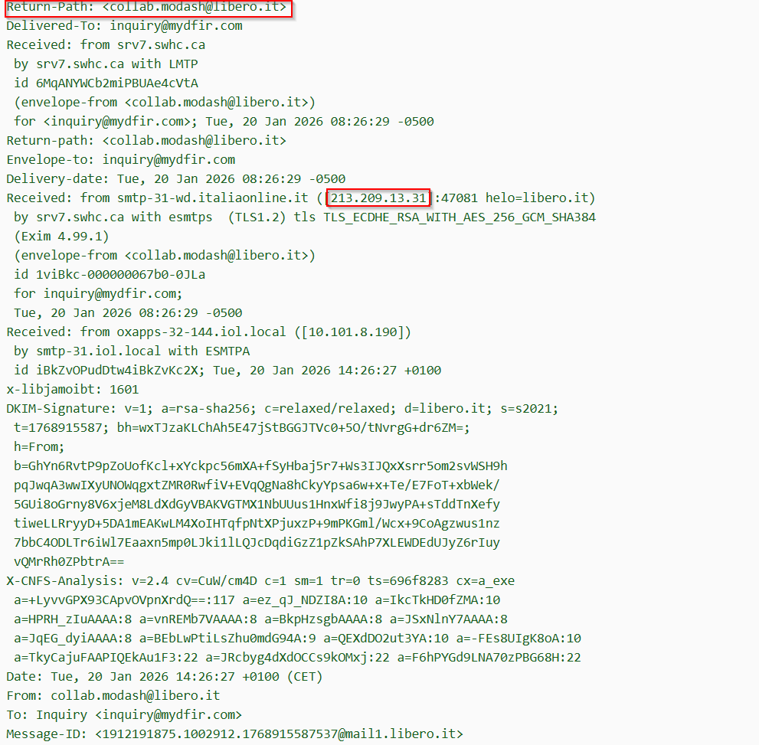

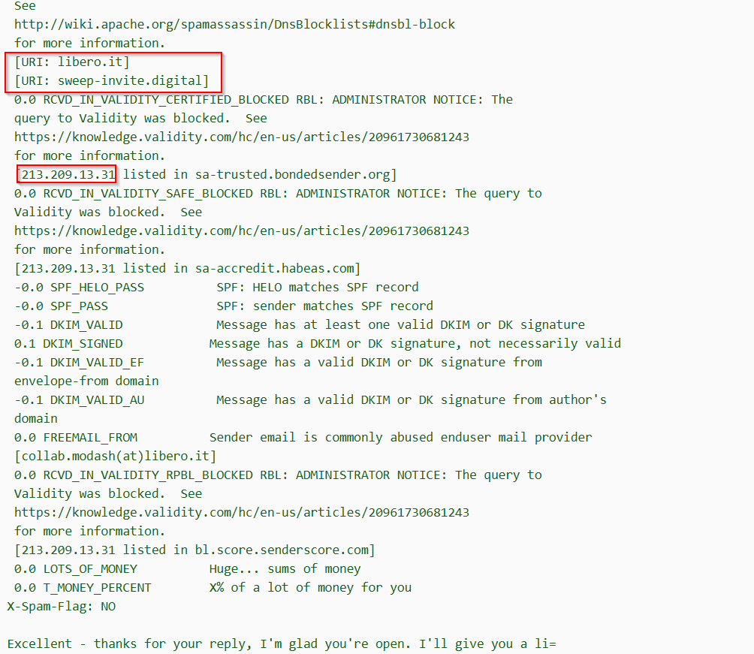
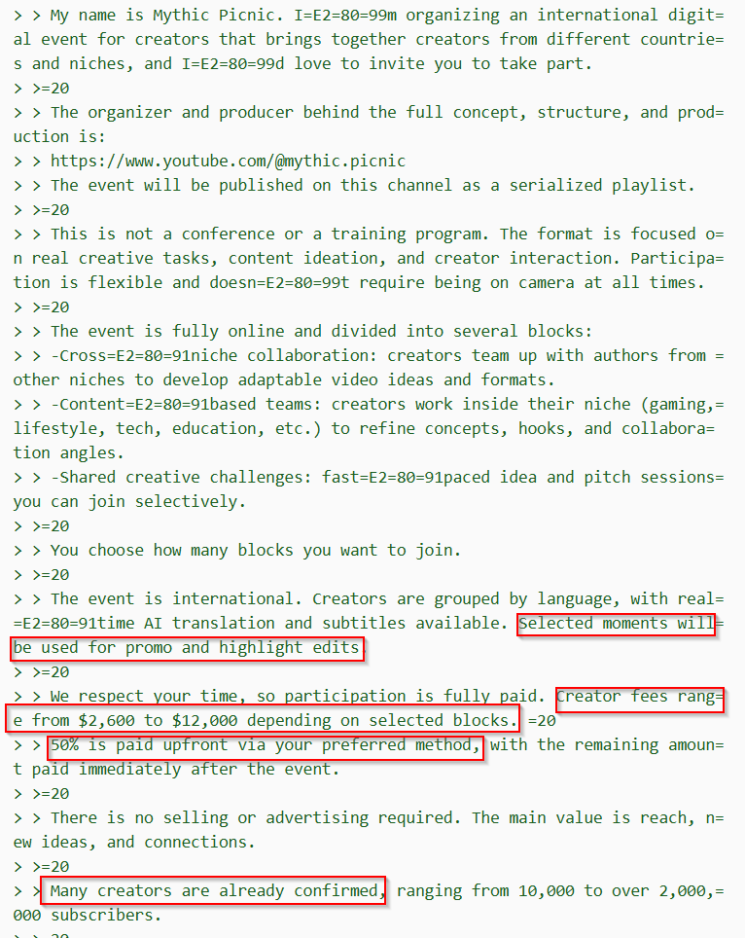
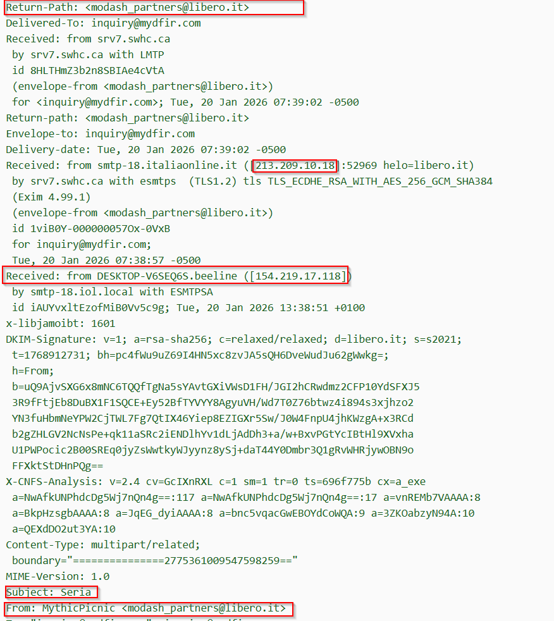

Domain Analysis
